[DCO-2453] Motive Financial - Authenticated signers "New Password" field requirements Created: 01/May/24 Updated: 06/May/24
Status: | In External Review
Project: | Journey Manager
Components: | None
Affects versions: | None
Fix versions: | Accessibility

Type: | Story | Priority: | None
Reporter: | Sanya Khandhuja | Assignee: | Fusi Olateru
Resolution: | Unresolved | Votes: | 0
Labels: | Motive, MotiveAuthenticated
Remaining Estimate: | Not Specified
Time Spent: | Not Specified
Original estimate: | Not Specified

Attachments: | image-20240501-132537.png
QA Bug Count: | 0
Days Open: | 2 days
Bug Count: | 0
Hours Variance: | 0
Hours Remaining: | 0
Hours Target PMO: | 0
Sprint:
Days Open: | 5

Description

The new password field contains a series of password requirements that are not immediately made aware to screen reader users.
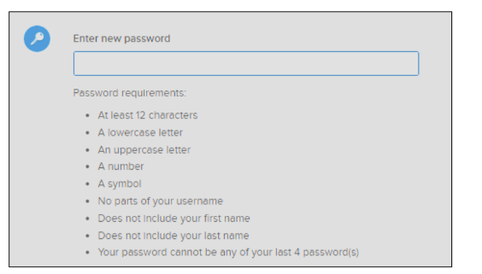
■ Recommendation: Use aria-describedby to automatically include the password requirement to the user when they enter the field. Alternatively, move the password requirements to be located prior to the input field.

Comments

Comment by Fusi Olateru [ 03/May/24 ]
okta
Generated at Mon May 06 21:48:14 UTC 2024 by Ian Hicks using Jira 1001.0.0-SNAPSHOT#100252-rev:aa264b414382dcd2bbea0c3e63c78e358e7de0d5.

